# Developing my values-led leadership toolkit

Welcome to your Developing my values-led leadership toolkit.

This is a guided online workbook which introduces content and a series of active and reflective exercises for you to work through, to help you align and embed personal values and organisational values into your own leadership practice.

The toolkit will help you to;

• Understanding and appreciate a values-led leadership style and learn what it means to be a values-led leader

• Develop and/or deepen a values-led leadership style

• Develop practical values-based actions and behaviours

## Contents

|  |  |  |
| --- | --- | --- |
| Section | Topic | Page |
| Why is values-led leadership so important? | How values-led leadership supports our universal values, global change strategy | 3 |
| Our organisational values | 4 |
| What is a values-led leader? | Leading with EQ (emotional intelligence) focusing on self-awareness and self-regulation | 6 |
| Leading inclusively with compassion | 10 |
| Leading with purpose | 12 |
| Leading authentically with trust, empathy and vulnerability | 13 |
| Building my values-led leadership style | My purpose | 15 |
| My personal core values | 19 |
| My strengths | 22 |
| My contribution | 25 |
| Building trust with my team | Validating my values-led leadership style | 28 |
| Aligning my values-led leadership | Aligning my personal values-led leadership style to our universal values, global change strategy and values | 30 |
| Deepening values-led leadership | Useful programmes and activities to develop your values-led leadership further | 33 |

## Section 1

## Why is values-led leadership so important?

How values-led leadership supports our Universal Values, Global Change Strategy.

In 2020 our Universal Values, Global Change Strategy was launched, a 10-year strategy with three key themes:

1. Culture – working together, collaborating and contributing to what the world needs.
2. Community – internal, external, local and global communities making a positive difference in the world
3. Impact – local, regional and international impact in research, education, links with business and the civic community and through continuous professional development.

[Click on this link to read more](https://spotlight.leeds.ac.uk/strategy/)

**Our mission**

Through collaboration with others, we harness our expertise in research and education to transform lives, advance knowledge and shape a better future for our community, our region and the world.

**Our vision**

Working with others, we will use our collective talents, expertise and shared endeavour in research and education to advance social justice, address global challenges and achieve UN Sustainable Development Goals.

Our students will become co-creators of their own dynamic and innovative educational experience, characterised by active learning, digital technologies and collaboration. They will thrive through a sense of belonging; they will feel valued for their unique contribution, and they will graduate equipped to make a difference as true global citizens.

**Our values and behaviours**

Our values will be at the heart of our decision making, activities and culture.

### Why is values-led leadership so important?

Read through the values below and reflect on how each is demonstrated in your role currently.

|  |
| --- |
| **Integrity - We are open and honest in our words and actions**  We do our best to make a positive difference  We are accountable for our actions  We protect freedom of expression and academic freedom and engage in constructive debate  We are honest, open minded and question assumptions |
|  |

|  |
| --- |
| **Inclusivity - We are a community where everyone is welcomed and belongs**  We create inclusive environments where everyone is listened to and supported to contribute, thrive and innovate  We support equality of opportunity and equality of outcome  We welcome, respect and value the diversity that individuals bring to our community |
|  |

|  |
| --- |
| **Compassion - We are caring and considerate in our words and actions**  We actively listen, respecting differing needs and points of view  We treat each other with kindness and empathy  We seek to understand different perspectives |
|  |

|  |
| --- |
| **Collaboration - We work together to achieve our goals and ambition**  We work with individuals, institutions, and nations to innovate and achieve our shared goals  We build and nurture relationships locally, nationally and globally  We recognise everyone’s contributions in our collective achievements and celebrate success |
|  |

### Reflective Activity

### Why is values-led leadership so important?

|  |
| --- |
| What does the Universal Values, Global Change Strategy mean for me as a leader? |
|  |

|  |
| --- |
| How do I, my team and my colleagues contribute to the strategic ambition? |
|  |

|  |
| --- |
| How do I, my team and my colleagues live our organisational values right now? |
|  |

## Section 2

## What is a values-led leader?

Values-led leadership identifies what is most important to you, your team and your colleagues and helps you to align that importance to provide direction, meaning and purpose to deliver a collective contribution.

Also referred to as values-based leadership, values-led leadership “instils a common set of values in all team members improving their cohesiveness and willingness to work together.”

This enables us to lead, collaborate, make decisions and innovate every day through a shared approach, to ensure individual and team contribution to deliver our Universal Values, Global Change strategy.

“Values are like fingerprints, nobody’s are the same but you leve them over everything you do”

Elvis Presley

Forbes, 2021 ranks the top 5 traits of values-led leaders as;

|  |  |
| --- | --- |
| Self-Reflection | Values-led leaders take time each day to reflect on their recent decisions and motivations, and as a result, are able to identify strengths and address blind spots in how they engage others, make decisions, and accurately communicate the vision. |
| Balance | Values-led leaders have the ability to look at situations from different viewpoints and integrate diversity of thought from the team while leveraging the core values in all decision-making. |
| Humility | Values-led leaders believe that every team member brings just as much value, if not more, to the organisation as they do, and continually ask “What can I do to be a better leader for you?” |
| Authenticity | Values-led leaders are honest and transparent with their teams, are highly self-aware and engage in the practice of improving emotional intelligence. |
| Continuous Improvement | Values-led leaders believe in asking for, and receiving honest feedback, continuous improvement, and life-long learning. |

Now rate yourself 1 (low) - 5 (high) as to how you feel you embody each value. Enter your rating in the box with each value.

[Click here to read the full Forbes article ‘5 Attributes (And Benefits) Of Values-Based Leadership'](https://www.forbes.com/sites/brentgleeson/2021/07/19/5-attributes-and-benefits-of-values-based-leadership/?sh=1eb4bbf23d21)

As well as the five traits, there are a variety of different styles of leadership theory that contribute to a values-led leadership approach. We have identified key leadership principles to help define a values-led leadership approach;

*On the following pages is a summary of leadership theory for each of the leadership principles, along with some links to additional resources that you may find helpful.*

### Leading with emotional intelligence

A simple definition of emotional intelligence (also called the Emotional Quotient, or EQ) is “ability to monitor your own emotions as well as the emotions of others, and to use emotional information to guide your thinking and behaviour and influence that of others” (Goleman, 1995; Mayer & Salovey, 1990)

EQ is no longer just a nice-to-have skill, but one of the World Economic Forum’s Top Ten skills to thrive in the fourth industrial revolution and could be considered the underpinning skill that can positively influence all others.

### Goleman’s 5 domains of EQ

Goleman says that our ability to become emotionally intelligent is not just innate – we are able to learn and develop it. (*Daniel Goleman, author of the Emotionally Intelligent Leader, 2019)*

|  |  |
| --- | --- |
| Personal Competence  (how we handle ourselves) | Social Competence  (how we handle relationships) |
| **Self-awareness:**  Knowing our internal states, preferences, resources, and intuitions. Includes:   * emotional awareness * accurate assessment of our strengths and limits * self-confidence | **Empathy:** Having awareness of others’ feelings, needs, and concerns. Includes:   * Understanding others * Developing others * Anticipating and meeting others’ needs * Leveraging diversity * Reading a group’s emotional currents and power relationships |
| **Self-regulation:** Managing our internal states, impulses, and resources. Includes:   * self-control of disruptive tendencies * trustworthiness * conscientiousness * adaptability to change * comfort with new ideas and approaches | **Social skills:**  Adeptness at inducing desirable responses in others. Includes:   * ability to influence others * clear communication * conflict management * leadership * ability to catalyse change * building bonds * collaboration and cooperation * ability to create group synergy |
| **Motivation:**  Moving toward achievement of goals. Includes:   * drive * commitment to a group’s or organisation’s goals * initiative * optimism in spite of obstacles or setbacks |  |

### Reflective activity

As a leader, where are my strengths and development areas in EQ?

|  |  |
| --- | --- |
| Strengths: | Development areas: |
|  |  |

Developing our EQ, our personal and social competence, will help us to identify our own values, help others to discover theirs to build a common set of values to improve collaboration, community and impact.

### Leading inclusively with compassion

Professor Michael West, of Kings Fund has studied compassionate and inclusive leadership extensively and supported leadership development in health and social care settings.

Compassionate leadership means leaders are paying attention to those they lead understanding the challenges and difficulties they face; empathising while being able to tolerate and not over-identify with staff difficulties; and taking thoughtful, appropriate action to help and support staff to do their jobs effectively.

Inclusive leadership hears all voices and empowers all to contribute to the achievement of high-quality, continually improving and compassionate care.

If we behave compassionately then we are we are automatically acting from a place of inclusivity - if we’re compassionate, then we include everybody, we seek to involve everybody, to listen to everybody, to empathise with everybody, to help everybody.

In our increasingly volatile, uncertain, complex and ambiguous environment, the directive ‘hero’ style of leadership will not work. We need collective and collaborative endeavour to be able to solve global issues and make positive impact. In 2016 Deloitte developed six signature traits of inclusive leadership to be able to navigate change, transformation and innovation.

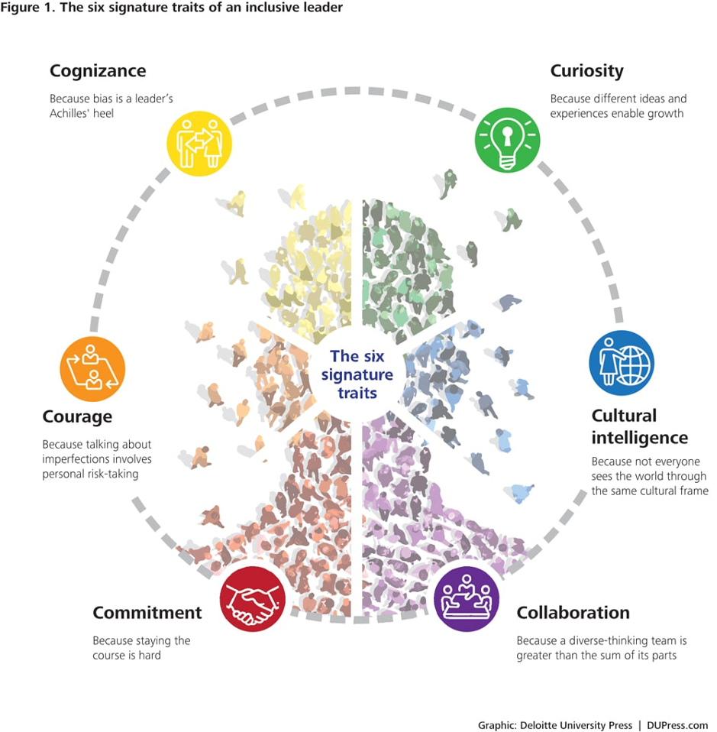

Circular diagram showing the 6 signature traits; cognizance, curiosity, cultural intelligence, collaboration, commitment and courage.

[Click here to hear from Professor Michael West](https://www.kingsfund.org.uk/audio-video/michael-west-leadership)

[Click here to go to the Deloitte article](https://www2.deloitte.com/us/en/insights/topics/talent/six-signature-traits-of-inclusive-leadership.html)

Here, we have brought together the four components of compassionate leadership and the six signature traits of inclusive leadership to provide an overview of approach and behaviours.

Rectangle divided into 4 with the components written aside: attending, understanding, helping and empathising. In the centre is part 2 (see separate description)
Inside is further information on the components - featuring curiosity, cultural intelligence, collaboration, commitment, courage and cognizance.

### Reflective activity

As a leader, where are my strengths and development areas leading compassionately and inclusively?

|  |  |
| --- | --- |
| Strengths: | Development areas: |
|  |  |

### Leading with purpose

Purposeful leadership is about connecting with personal, team and organisational purpose and being purposeful about contribution and task.

Purposeful leadership ensures we achieve our goals on both a human and task level and so we need to understand the organisation’s purpose (mission and vision) and how we can achieve it.

Then we can align our individual and team purpose to enable us to see the part we are playing in the bigger picture.

OD&PL have a number of facilitated values workshops to help you embed values within your team, with one specifically focusing on the alignment of individual and team purpose to the organisation’s mission.

Please contact OD&PL for more information.

[Click here to read more about the university strategies and values](https://www.leeds.ac.uk/about/doc/strategies-values#:~:text=Our%20mission,our%20region%20and%20the%20world)

[Click here to go to the OD&PL website](https://peopledevelopment.leeds.ac.uk/contact-us/)

### Leading authentically

If we lead authentically, we inspire those we lead because we are self-aware, develop open and transparent relationships, stay true to our values and behave with integrity.

We can inspire loyalty and trust in our teams by consistently displaying who we really are as a person, and how we feel about our work. This means leading by example, demonstrating through our actions that we practice the same shared values and behaviours that we expect from our team.

Bill George, author of True North; Discover you Authentic Leadership introduces us to the analogy that accessing and following your own internal compass will enable you to be authentic and he talks about the internal compass starting with…

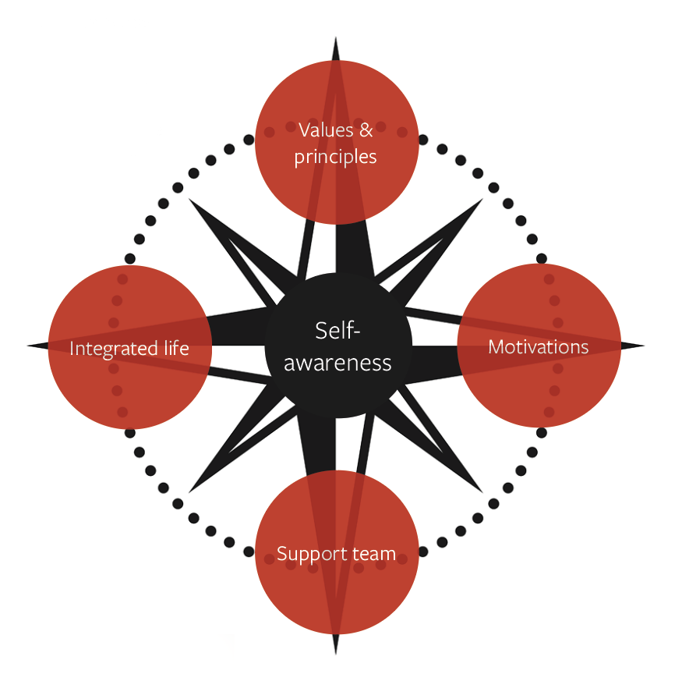

Our next section will help you build your own authentic leadership narrative to develop your values-led leadership style.

Building your authentic leadership narrative will clarify your purpose, your core values, your strengths and contribution, which can become the compass for your values-led leadership.

We have an exercise for you to complete for each level of the leadership narrative framework.

We are asking you to reflect deeply on yourselves, and as such you may find this uncomfortable, especially if you have a more active style of learning. As such here are some top tips to help you get the best from the exercises:

* Try to carve out some dedicated time to focus and build in activity and breaks in between exercises to top up your energy!
* Even better if you can do them in a different environment than you are used to working in, maybe some green space or a place that you consider relaxing, inspiring and comfortable.
* You may need to circle back on the activities. These are deep questions and so you unlikely to land on a truly authentic narrative first time.
* Enjoy the time you are investing to think about yourself – we so rarely get the opportunity to do this!

## Section 3

## Building my values-led leadership style

### Exercise 1 - My purpose: the reason I do what I do

We are starting at the top of the pyramid purposefully, as when we understand why we do what we do, it can help to engage us positively to open up our thinking about our values, strengths and contribution.

[Watch this video to help you think about your leadership purpose](https://www.youtube.com/watch?v=hUsOGUZimjk)

Here are some specific benefits:

**Impact:** Purpose boosts our capacity to make the greatest impact in the work we do

**Connection:** It can help us connect with other people across cultures and contexts

**Motivation:** We feel energized, motivated and expanded when we have a sense of purpose

**Satisfaction:** People who consider their work to be a calling tend to be more satisfied than those who think of their work as “just” a job

**Resilience:** Having a purpose can help us overcome obstacles

**Momentum:** Immediate, short-term goals may not be enough to motivate us enough but if we understand our greater purpose and keep that it mind it can keep our focus through challenging times

### Identifying my purpose with Ikigai

Ikigai is a Japanese word that translates roughly to “a reason for being”. The Ikigai framework breaks activity into four categories:

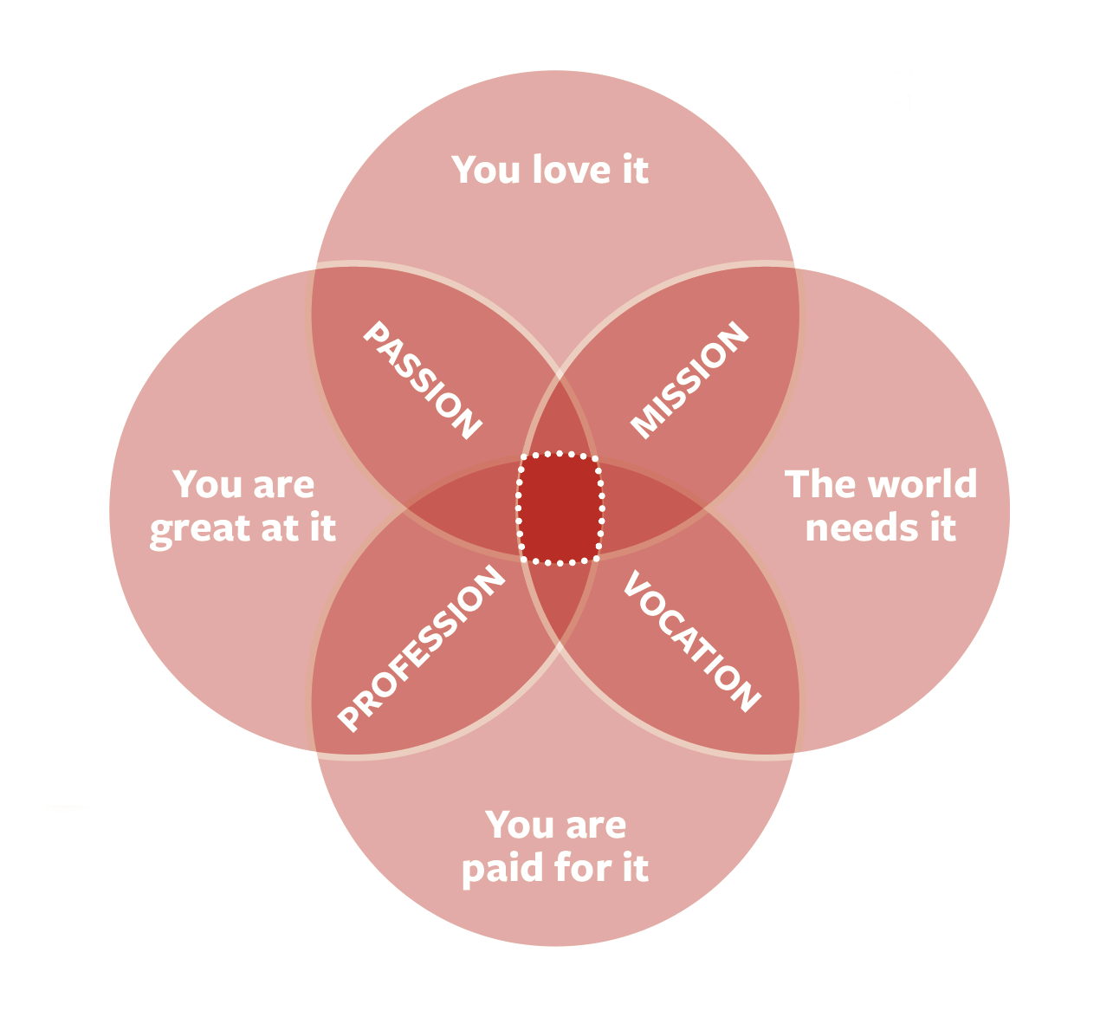 The centre spot is called “Sense of Purpose” and represents situations where you can get paid to solve critical world needs in an environment you not only love but where your talents are put to good use.

Passion is the intersection of “things you love” and “things you are good at.” If there is a lack of passion in your work, ask yourself if you are spending too much time on things you are not good at or don’t care about.

Mission is the intersection of “things you love” and “things the world needs.” A driving cause that is close to your heart.

Profession is at the intersection of “things you are good at” and “things you can get paid for doing.” Hopefully professions are fulfilling, but they are sometimes not and we gain fulfilment in different ways, so we need to think the next category.

Vocation is at the intersection between “what the world needs” and “things you can get paid for.” Where you are making a meaningful impact in the world.

#### Step 1 - Reflective questions

Take some time to reflect on these questions and make notes:

|  |
| --- |
| What makes you smile? (Activities, people, events, hobbies, projects, etc.) |
|  |

|  |
| --- |
| What were your favourite things to do in the past? What about now? |
|  |

|  |
| --- |
| What activities in work make you lose track of time? |
|  |

|  |
| --- |
| What makes you feel great about yourself? |
|  |

|  |
| --- |
| Who inspires you most? (Anyone you know or do not know - family, friends, authors, artists, leaders, etc.) |
|  |

|  |
| --- |
| Which qualities inspire you, in each person? |
|  |

|  |
| --- |
| What causes do you strongly believe in? Connect with? |
|  |

|  |
| --- |
| If you could get a message across to a large group of people, who would those people be? |
|  |

|  |
| --- |
| What would your message be? |
|  |

#### Step 2 - Developing my Ikigai

You may find it helpful to work on some flip chart paper and draw out the four circles; Passion, Profession, Vocation, Mission.

Spend 5-10 minutes on each of the four circles, reflecting on your answers in step 1 and write down the strongest ideas that come to mind for each question.

#### Step 3 - My purpose

After making notes for each circle, look for the overlaps and common themes and add them to the intersection of the four circles.

Now write a single sentence that expresses your sense of purpose. This is your personal statement or your mission statement.

|  |
| --- |
|  |

### Exercise 2 - My values: Core values, attitudes, beliefs that guide me

Personal values are:

**‘broad desirable goals that motivate people’s actions and serve as guiding principles in their lives’**

Schwartz, 1992

Values are what is important to us; 3-5 core values that identify who we are at our core and we can think of them as anchors that ground us.

Each person’s values are unique; even if two people happen to pick the same value word, such as ‘integrity’, each person will demonstrate it differently in their daily actions and language.

As well as helping us to led with a values-led approach, there are more benefits of understanding and working with your core values.

[Click on this article to learn more](https://medium.com/@scoutcoaching/core-values-what-they-are-why-they-matter-and-how-to-define-yours-93164383eada)

#### Step 1 - Values sort

From this list of values (both work and personal), select the nine that are most important to you - guides for how to behave or as components of a valued way of life. Feel free to add any values of your own to this list.

Feel free to add your own values to this list.

|  |  |  |
| --- | --- | --- |
| Achievement | Friendships | Physical challenge |
| Advancement / Promotion | Growth | Pleasure |
| Adventure | Having a family | Power and authority |
| Affection / Love / Caring | Helping other people | Privacy |
| Arts | Helping society | Public service |
| Challenging problems | Honesty | Purity |
| Change / Variety | Inclusivity | Quality of what I take part in |
| Close relationships | Independence | Quality relationships |
| Collaboration | Influencing others | Recognition / Respect / Status |
| Compassion | Inner harmony | Religion |
| Community | Integrity | Reputation |
| Competence | Intellectual status | Responsibility / Accountability |
| Competition | Involvement | Security |
| Cooperation | Job tranquility | Self-respect |
| Creativity | Knowledge | Serenity |
| Decisiveness | Leadership | Sophistication |
| Democracy | Location | Stability |
| Ecological awareness | Loyalty | Status |
| Economic security | Market position | Supervising others |
| Effectiveness | Meaningful work | Time freedom |
| Efficiency | Merit | Truth |
| Ethical practice | Money | Trust |
| Excellence | Nature | Wealth |
| Excitement | Openness / Honesty | Wisdom |
| Fame | Order / Stability | Work under pressure |
| Fast living | Personal development | Work with others |
| Financial gain | Freedom | Working alone |
| *Add your own:* | | |

Step 2 – Refine

Narrow your 9 most important values down to 5.

|  |  |  |
| --- | --- | --- |
|  |  |  |

|  |  |
| --- | --- |
|  |  |

Step 3 - Identify

Narrow down your five most important values to three.

**My personal core values:**

|  |  |  |
| --- | --- | --- |
|  |  |  |

### Exercise 3 - My strengths: My standout and significant strengths, skills and experience

Strengths are defined as :

**‘‘underlying qualities that energise you and that you are great at or have the potential to become great at’**

Strengthscope, 2023

Strengths reflect our purpose and values and enable us to perform at our peak, in both good times and during tough, challenging times. Knowing our strengths helps with greater vitality and motivation, a clearer sense of direction, higher self-confidence, productivity and a higher probability of goal attainment.

If we work with our strengths and encourage others too, it enables us to focus on what unique qualities each of us contribute. This develops a sense of feeling included and being valued, helping to build a sense of belonging.

[Listen to this podcast to learn more about inclusion through strengths](https://www.strengthscope.com/podcasts/diversity-and-inclusion-how-strengths-can-help)

#### Step 1 - Reflective questions

|  |
| --- |
| Note down a particular career highlight and what made you feel proud or good about it? |
|  |

Think about your best day at work….

Think about a good day, a day when everything goes well, you’re totally absorbed, and you lose track of time, when you reflect back and feel you had made a difference?

|  |  |
| --- | --- |
| What are you doing? |  |
| What are you thinking? |  |
| How are you feeling? |  |
| What are the strengths and positive qualities you are known for?  What would your immediate family say about you? |  |
| What would a close friend say about you? |  |
| What would your work colleagues say about you? |  |

#### Step 2 - Identify your strengths

Identify the common themes from your reflections to identify your 5 significant strengths and note them down.

My five significant strengths:

|  |  |  |
| --- | --- | --- |
|  |  |  |

|  |  |
| --- | --- |
|  |  |

### Exercise 4 - My contribution: The value I want to contribute to an organisation, and why others would want to follow

To help complete your leadership narrative we will use visualisation techniques to develop a leadership vision, which will help you to think about the contribution you would like to make.

#### Step 1 - Preparation

Find a quiet space where you won’t be disturbed, somewhere you feel relaxed and comfortable

Close your eyes and take some deep breaths until you feel calm and comfortable

Imagine it is a leadership awards night... you have been nominated as the leader of a complex, valuing adding and successful transformation or innovation project or programme... for example:

* A ground-breaking piece of research
* A transformative new degree programme that exceeds student expectations and opportunities for employment
* A successful partnership collaboration with another university or organisation that provides a blue print for best practice in partnerships
* A project that has contributed to the mission of the University of Leeds; through collaboration with others, we harness our expertise in research and education to transform lives, advance knowledge and shape a better future for our community, our region and the world.

Now imagine your trusted colleague is going to make a speech about you, your leadership style and your contribution to the organisation.

Imagine how you are thinking and feeling as your colleague is approaching the stage to talk about you...

Capture the kind of words you would like your colleague to say about you as a leader:

|  |
| --- |
|  |

What you would you like your colleague to say about how you led your people through this successful and transformative project or programme?

|  |
| --- |
|  |

What you would like people to say about you after the event?

|  |
| --- |
|  |

#### Step 2 – Identifying your Contribution

Reflect on your notes from the visioning exercise above and identify your contribution in one sentence.

My Contribution:

|  |
| --- |
|  |

Now reflect back on your purpose statement, does it align with your contribution, do you need to amend it in any way?

My Updated Purpose (if required):

|  |
| --- |
|  |

#### My authentic leadership narrative

Complete your authentic leadership narrative template by adding your:

* Purpose statement
* Three personal core values
* Five significant strengths
* Contribution statement

### Exercise 5 – My authentic leadership narrative

Build your authentic leadership narrative by bringing together your 3 core values, your 5 standout strengths, your contribution statement and your purpose statement.

|  |  |
| --- | --- |
| **My purpose**  The reason I do what I do. |  |
| **My contribution**  The value I want to contribute to our organisation and why others would want to follow me |  |
| **My standout strengths**  My standout and significant strengths/ skills / experience |  |
| **My values**  Core values, attitudes, beliefs that guide me |  |

Reflect on the overall template:

* Does it align?
* Does it feel right for you?
* Would you feel comfortable sharing it with others?

|  |
| --- |
|  |

## Section 4

## Building trust with my team

### Exercise 3 - My strengths: My standout and significant strengths, skills and experience

As values-led leaders we need to be open, transparent and authentic with our colleagues, and so we need to be comfortable with vulnerability and humility.

Values-led leadership requires that we reveal more about ourselves, our own personal values and what is important to us, encouraging them to share what’s important to them with us. We also need to think about how we can share more about ourselves as a team collectively, to develop our set of shared values.

Learn more about the important of showing vulnerability as a leader to build trust by watching this video from Patrick Lencioni, author of the Five Dysfunctions of a Team.

[Watch Five Dysfunctions of a Team](https://www.youtube.com/watch?v=pbWEDk8fbBU)

### Validating my values-led leadership style

You have built your authentic leadership narrative through reflection and deepening your self- awareness, however to be truly authentic, it’s important that you obtain the perspectives of others too, to complete the picture.

Forbes (the article we visited earlier on page 5) identify that continuous improvement and feedback is a key attribute of values-led leadership and building a feedback culture within your team starts with you. By asking for feedback first, both positive and developmental, it is much more likely to be received positively.

#### Action exercise - Sharing my leadership narrative

Share your leadership narrative with your team (either 121 or in a group) and encourage them to reflect on it.

Ask them:

* What resonates for them?
* What is missing from their perspective?
* Do they see the themes in your leadership style and behaviour?
* What could you do differently to make these themes more visible to them?

Don’t forget to make any adaptations as a result that you think would be helpful.

By sharing your values, strengths, contribution and purpose you are building trust with your team and encouraging them to share what is important to them too.

#### Action exercise - team members narratives

Encourage your team members to complete the exercise too, the template and exercises can be adapted to reflect individual contribution rather than leadership.

This will help them to develop their own self-awareness and an awareness of each other to work even more effectively together.

OD&PL have a number of facilitated values workshops to help you embed values within your team. Please contact OD&PL for more information.

[Click here for the Embedding values with my team toolkit](https://peopledevelopment.leeds.ac.uk/contact-us/)

#### Action exercise - make it visible

Finally display your leadership narrative somewhere visible to you – use it as your blue-print - to remind you of the leader you want to be, especially when times are challenging,

Remember to review it from time to time, to check it feels right for you.

## Section 5

## Aligning my values-led leadership

Now we have a clearer understanding of what is important to us personally, we need to think about how we can align that to the University’s mission, vision and values. By aligning what’s important to us personally, we are much more likely to be engaged, satisfied and successful as leaders and teams.

Listen to the link between organisation values and personal values from Dr Susan David, Business Psychologist and author of Emotional Agility.

So how can we make the link between organisational and individual values?

[Listen to Dr Susan David](https://www.youtube.com/watch?v=lTjdMg8tnZY)

### Reflective activity - Review your initial thoughts

Review the first exercise you completed for section 1 - **why is values-led leadership so important?**

* What does the Universal Values, Global Change Strategy mean for me as a leader?
* How do I, my team and my colleagues contribute to the strategic ambition?
* How do I, my team and my colleagues live our organisational values right now?

With your deeper self-awareness do you have any further insights to those questions.

|  |
| --- |
|  |

### Reflective activity – aligning my leadership narrative

Using your leadership narrative here are some reflective questions that may help.

#### Aligning my purpose and contribution

|  |
| --- |
| Reflect on your purpose and contribution statements. Consider how closely aligned it is to the University’s mission and vision – can you see your part in the bigger picture? |
|  |

|  |
| --- |
| What one small bold step can you take right away to move your personal sense of purpose to contribute further to the closer to the University’s mission and vision. |
|  |

#### Aligning my personal core values

How do your personal core values help you to live our organisational values?

What specifically can you do to bring them in closer alignment?

|  |  |
| --- | --- |
| **Integrity -**   * We are open and honest in our words and actions * We do our best to make a positive difference * Are accountable for our actions * We protect freedom of expression and academic freedom and engage in constructive debate * We are honest, open minded and question assumptions |  |
| **Inclusivity -**   * We are a community where everyone is welcomed and belongs * We create inclusive environments where everyone is listened to and supported to contribute, thrive and innovate * We support equality of opportunity and equality of outcome * We welcome, respect and value the diversity that individuals bring to our community |  |
| **Compassion -**   * We are caring and considerate in our words and actions * We actively listen, respecting differing needs and points of view * We treat each other with kindness and empathy * We seek to understand different perspectives |  |
| **Collaboration -**   * We work together to achieve our goals and ambition * We work with individuals, institutions, and nations to innovate and achieve our shared goals * We build and nurture relationships locally, nationally and globally * We recognise everyone’s contributions in our collective achievements and celebrate success |  |
| **Alignment with strengths -**   * How can my strengths help me to contribute to the delivery of the Universities strategic themes; community, culture and impact? |  |

## Section 6

## Deepening my values-led leadership

OD&PL have a number of facilitated values workshops to help you embed values within your team. Please contact OD&PL for more information.

[**Embedding values with my team toolkit**](https://peopledevelopment.leeds.ac.uk/contact-us/)

#### Open leadership programmes

[**Discovering your leadership**](https://peopledevelopment.leeds.ac.uk/contact-us/)for new and aspiring leaders

[**Establishing your leadership**](https://leadershipandprofessionalpractice.leeds.ac.uk/home/leadership/leadership-development/establishing-your-leadership/) for leaders who would like to strengthen their leadership experience around the values of inclusivity, integrity, compassion and collaboration

[**Leading transformational change**](https://leadershipandprofessionalpractice.leeds.ac.uk/home/leadership/leadership-development/leading-transformational-change/)to help leaders plan, accelerate and embed change effectively

#### Useful leadership toolkits

[**Developing your emotional intelligence**](https://leadershipandprofessionalpractice.leeds.ac.uk/home/leadership/leaders-toolkit/developing-your-emotional-intelligence/)

[**Emotional intelligence assessment**](https://leadershipandprofessionalpractice.leeds.ac.uk/home/staff-development/psychometrics/) to give further insight on your strengths and development areas in EQ

[**Purposeful leadership**](https://leadershipandprofessionalpractice.leeds.ac.uk/home/leadership/leaders-toolkit/purposeful-leadership/)

[**Collaboration**](https://leadershipandprofessionalpractice.leeds.ac.uk/home/leadership/leaders-toolkit/collaboration/)

[**Leading and managing change**](https://leadershipandprofessionalpractice.leeds.ac.uk/home/leadership/leaders-toolkit/managing-change/)

#### Other resources

[**Equality and inclusion development**](https://leadershipandprofessionalpractice.leeds.ac.uk/home/staff-development/equality-inclusion/)